**Aptech**

Global Learning Solutions Company

**ACCP AI**

CPISM

AI-202411B

E-Project

**Cell INFO Website**

**BY:**

Asra Asif

Suleman Aston

Hamza Shareef

**Supervised By**

Miss Faiqa Talib

**Table of Contents**

**Acknowledgment** 3

**Synopsis** 4

**Objective:** 5

**Requirement Summary** 5

**1. Home Page** 5

**2. Navigation Menu** 5

**3. Brand-Based Filtering** 6

**4. Mobile Phone Information** 6

**5. Comparison Page** 6

**6. Color Scheme** 6

**7. Brand-Specific Background** 7

**8. Contact Us Page** 7

**9. Data Source** 7

**10. Web Development Tools** 7

**11. UI & UX Considerations** 7

**Analysis** 8

**Problem Statement** 8

**Proposed Solution** 8

**Source Code with Comments** 9

**Home Page** 9

**About Page** 9

**Comparison Page** 10

**Features Page** 10

**Contact Us Page** 11

**Screenshots of Website** 11

**Hero Section** 11

**Latest Phones Section** 12

**Quiz &Contact Us Section** 13

**Footer** 13

**User Guide** 14

**1. Home Page** 14

**2. About Page** 14

**3. Menu & Filtering** 14

**4. Phone Details Page** 14

**5. Comparison Page** 15

**6. Interactive Quiz Feature** 15

**7. Contact Us Page** 15

**Additional Features** 15

**Developer Guide** 16

**Development Guidelines** 16

**Frontend Guidelines** 16

**JavaScript & jQuery Guidelines** 16

**Data Handling** 16

**Deployment & Maintenance** 17

**Hosting** 17

**Version Control** 17

**Planned Upgrades (Insha'Allah)** 17

**Contact & Support** 17

**Conclusion** 18

# **Acknowledgment**

I am sincerely grateful to Almighty Allah for granting me the strength and perseverance to complete this project.

I would like to extend my heartfelt gratitude to **Aptech,** **Sir Muhsin**, and **Miss Faiqa Talib** for their valuable guidance and continuous support. Their assistance has been instrumental in the successful completion of this project.

I also appreciate my friends and family for their constant motivation and encouragement, which kept me focused and determined throughout the project.

# **Synopsis**

**Project Name: ASKME_MOBILE**

## **Objective:**

The objective of this project is to develop a user-friendly, single-page website that provides users with detailed information about mobile phones. The website will serve as a reliable platform for users to search, compare, and explore different mobile phone models based on their features and specifications.

This project aims to:

* Provide a real-life learning experience for students.
* Enhance practical knowledge of web development using **HTML, CSS, Bootstrap, JavaScript, and jQuery**.
* Simulate an actual business problem and deliver a structured solution.

# **Requirement Summary**

Based on the management's decision regarding the website, the following requirements have been outlined:

## **1. Home Page**

* The home page should have proper sections, graphics, and a logo.

## **2. Navigation Menu**

* A structured menu should be available, categorizing different sections of the website, such as:
  + Mobile Brands
  + Phone Features
  + Comparison
  + Contact Us

## **3. Brand-Based Filtering**

* Users should be able to filter mobile phones by brand (e.g., Nokia, Samsung, Apple, etc.).
* Clicking on a brand should display only that brand’s models.

## **4. Mobile Phone Information**

* A summary of each phone’s features should be displayed on the webpage.
* Detailed features should be provided in downloadable Word documents.

## **5. Comparison Page**

* A separate page should allow users to compare different models based on their features.
* The comparison should be presented in a **tabular format**.
* The page should support comparison for:
  + 5 phones of the same brand
  + 2 phones of different brands
* The comparison data should be updated every **one month**.

## **6. Color Scheme**

* The website should have a soothing pastel color theme for a better user experience.

## **7. Brand-Specific Background**

* When viewing a particular brand’s phones, the page background should display the **brand's logo**.

## **8. Contact Us Page**

* The page should include the company's official contact details:
  + **Company Address:** A-65, ACME Co., Street No. 12, New York
  + **Phone Numbers:** +001-28272300, 2466, 2469
  + **Email Address:** [webmaster@cellinfo.com](mailto:webmaster@cellinfo.com)
* Clicking the email address should open the default email client.

## **9. Data Source**

* Information regarding mobile phones should be fetched from official brand websites (e.g., **Nokia, Samsung, Apple**).

## **10. Web Development Tools**

* The website should utilize **HTML, CSS, Bootstrap, JavaScript, and jQuery**.
* Dreamweaver components like layers, flash buttons, and other interactive elements can be used to enhance the UI.

## **11. UI & UX Considerations**

* The website’s layout and organization should be intuitive.
* A well-structured and visually appealing interface will enhance the project’s evaluation score.

# **Analysis**

## **Problem Statement**

ASKME Ltd., a multinational company, provides information services via telephone calls. A significant portion of queries received by their call executives is related to mobile phones, including:

1. Model numbers with specific features.
2. Feature details of mobile models.
3. Current market prices.
4. Comparisons between different mobile models.

Since addressing these queries via phone consumes significant time and resources, the **Board of Directors** has proposed a solution:

* Launching an online platform, **CELLINFO.com**, where users can access detailed mobile information on a single click.

## **Proposed Solution**

To resolve the identified issues, we propose a **responsive, single-page website** that:

* Allows users to **search** and **filter** mobile models based on brand and features.
* Displays **detailed specifications** and pricing of mobile phones.
* Offers a **comparison tool** for analysing different models.
* Provides a **downloadable document** with additional details.

# **Source Code with Comments**

## **Home Page**

## **About Page**

## **Comparison Page**

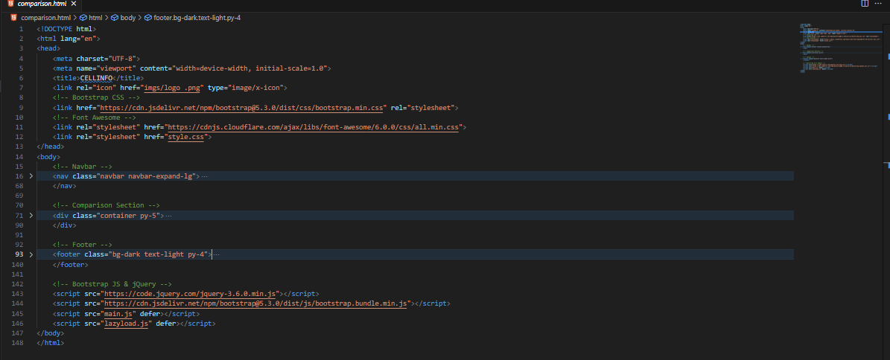

## **Features Page**

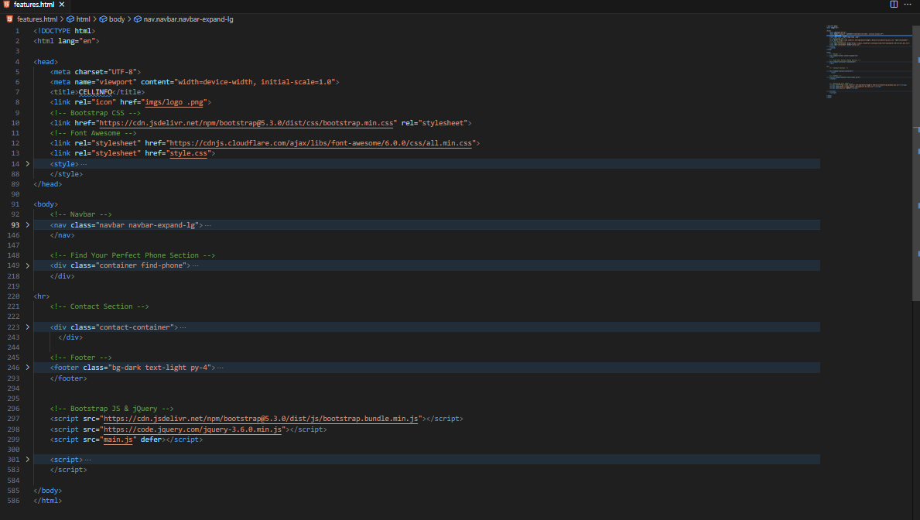

## **Contact Us Page**

# **Screenshots of Website**

## **Hero Section**

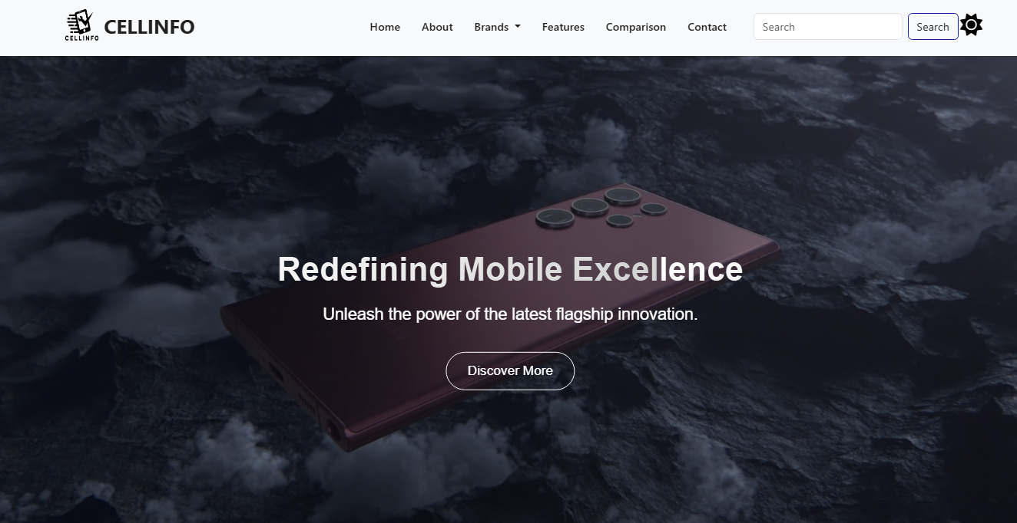

**About Section**

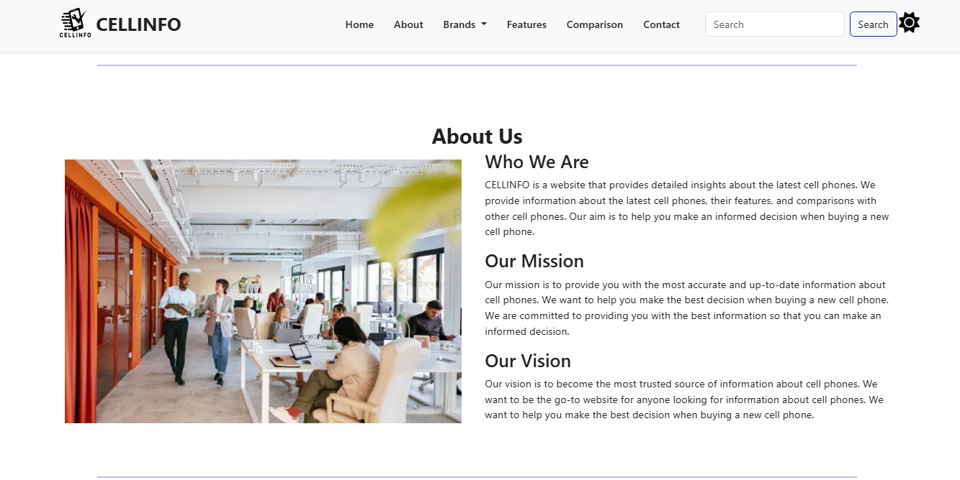

## **Latest Phones Section**

## **Quiz &Contact Us Section**

## **Footer**

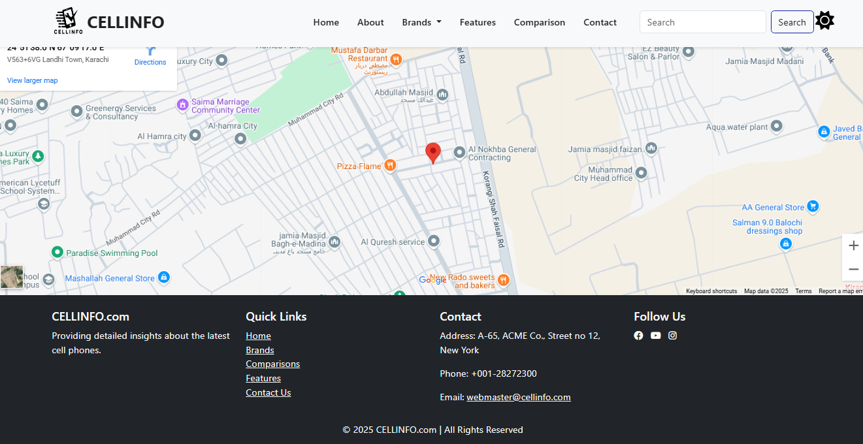

# **User Guide**

## **1. Home Page**

* The home page contains an overview of the website with a **hero section** that includes a slider displaying featured mobile phones.
* A toggle feature allows users to switch between different views.
* The menu bar provides quick access to various sections of the website.

## **2. About Page**

* The **About Page** provides an overview of the purpose and mission of Cell Info.
* It includes details about the team behind the website and the motivation for creating this platform.
* Users can learn about the data sources used to compile mobile specifications.

## **3. Menu & Filtering**

* Users can navigate to specific phone categories through the **menu bar**, which categorizes phones based on brand (e.g., Nokia, Samsung, etc.).
* A **filter feature** allows users to select phones based on their preferred brand, price range, and features.
* The **Brands Page** includes separate sections for different brands, where users can explore phone models and download detailed specifications.

## **4. Phone Details Page**

* Clicking on any phone model will open a detailed page displaying its specifications and key features.
* Users can download a document containing in-depth specifications for offline reference.

## **5. Comparison Page**

* The comparison page enables users to select multiple phone models and compare their features using **both card-based and tabular formats**.
* This helps users make an informed decision before purchasing a phone.

## **6. Interactive Quiz Feature**

* The website includes an interactive quiz with 5 questions.
* Based on the user's answers, the system will suggest the most suitable mobile phone model.
* This feature helps users find a phone that matches their preferences and needs.

## **7. Contact Us Page**

* Users can reach out for inquiries or support through the **Contact Us** page, which provides company details and a contact form.

## **Additional Features**

* **Responsive Design:** The website is fully optimized for both desktop and mobile devices.
* **User-Friendly Interface:** Simple and intuitive navigation ensures a seamless browsing experience.
* **Dark Mode & Light Mode:** Users can switch between dark and light themes according to their preference. The selected mode will be saved for a consistent experience.

# **Developer Guide**

## **Development Guidelines**

## **Frontend Guidelines**

* Use Bootstrap grid system for responsiveness.
* Maintain a consistent color scheme (pastel colors).
* Implement smooth scrolling between sections.
* Optimize images for faster loading.

## **JavaScript & jQuery Guidelines**

* Use event handlers for interactive elements.
* Implement AJAX calls to fetch mobile data from phones.json.
* Ensure smooth animations for UI elements.
* Use localStorage to remember dark mode preferences.

## **Data Handling**

* Store phone data in phones. json
* Update the JSON file when adding new models.
* Ensure proper validation when parsing JSON data.

## 

# **Deployment & Maintenance**

## **Hosting**

* **Deploy on GitHub Pages, Netlify, or Vercel.**

## **Version Control**

* Use Git for version tracking.
* Push updates to the GitHub repository.

## **Planned Upgrades (Insha'Allah)**

To elevate your experience, **Cell Info** will soon introduce:

**AI-Powered Chatbot**

* Instant, intelligent responses to your device-related queries.

**Real-Time Price API Integration**

* Live market updates for accurate pricing insights.

“Innovation is turning imagination into reality.”

We’re committed to making **Cell Info** smarter and more responsive for you.

# **Contact & Support**

**For development issues or contributions, reach out via email or GitHub repository.**

**Happy Coding!**

# **Conclusion**

**Cell Info** is a user-friendly platform that provides detailed mobile phone information, including brand-wise filtering and model comparisons. It makes decision-making easier and enhances accessibility with features like dark mode.

Its purpose is to help users choose the right mobile by providing accurate and up-to-date information. Future updates may include AI recommendations and user reviews for better engagement.

Overall, **Cell Info** effectively combines technology and convenience for a seamless user experience.

Thank you for your time and interest in **Cell Info**. We truly appreciate your engagement and hope our platform delivers valuable insights to meet your needs.

Should you have any questions, feedback, or suggestions, please do not hesitate to reach out we’re here to help.

As Carly Fiorina aptly once said**,**

**“The goal is to turn data into information, and information into insight.”**

At Cell Info, we strive to embody this vision every day. We look forward to assisting you further.

**Thank You!**